Prompts
You are an ontology engineer and legal informatics researcher.
Your task is to build a proof-of-concept ontology for the EU AI Act and generate a small reproducible project including ontology files and code.
Ontology structure:
The ontology should follow the hierarchical structure:
├── AI_System
│ ├── Prohibited_AI_Practice
│ ├── High_Risk_AI_System
│ ├── Certain_AI_System
│ └── General_Purpose_AI_Model
├── Actor
│ ├── Provider
│ ├── Deployer
│ ├── Distributor
│ ├── Importer
│ └── Authority
├── Obligation
└── Governance

Tasks
1. Ontology modelling
Extend the hierarchy by proposing reasonable subclasses for Obligation and Governance based on the EU AI Act.
Define relationships between actors, AI systems, obligations and governance entities (e.g. subject_to_obligation, regulates, deploys, governs).
Include basic annotations:
- rdfs:label
- short description
- EU AI Act article reference
Keep the ontology lightweight but consistent with the EU AI Act.
Reuse existing ontology design patterns where possible.
2. AI-assisted pipeline
Design an AI-assisted ontology construction workflow including:
- concept extraction from EU AI Act text
- ontology modelling
- validation
Include a human-in-the-loop stage where a domain expert reviews the extracted concepts and ontology structure.
3. Competency questions
Define 3–5 competency questions that the ontology should answer.
4. SPARQL queries
Provide example SPARQL queries that answer the competency questions.
5. Evaluation
Define simple evaluation metrics for ontology quality such as:
- annotation coverage
- relation completeness
- competency question coverage.

Requirements for generated files
Ontology file
- Turtle (.ttl) format
- include classes, properties and example triples
Python scripts
- use rdflib
- include clear comments
- demonstrate extraction, modelling and validation steps

Validation
- include SHACL shapes or simple Python validation

Ensure the project is small, readable and suitable as a proof-of-concept ontology engineering assignment.

Competency questions and SPARQL queries
CQ1: Which high-risk AI systems are represented and which obligations apply to each?
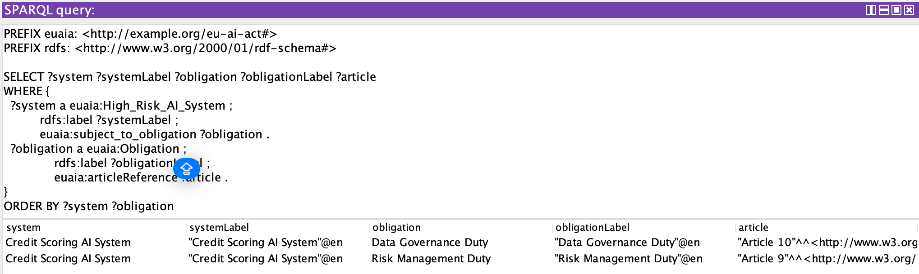
CQ2: Which actors are subject to which obligations?
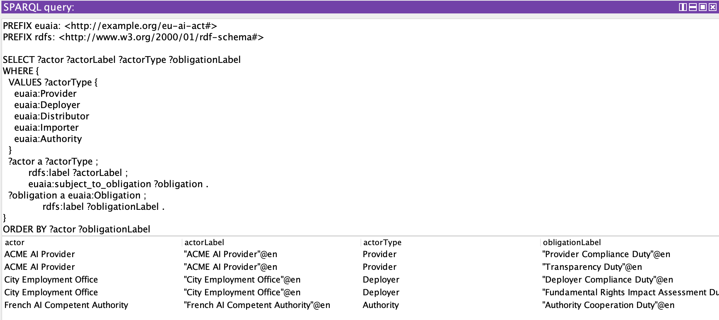
CQ3: Which prohibited AI practices are represented?
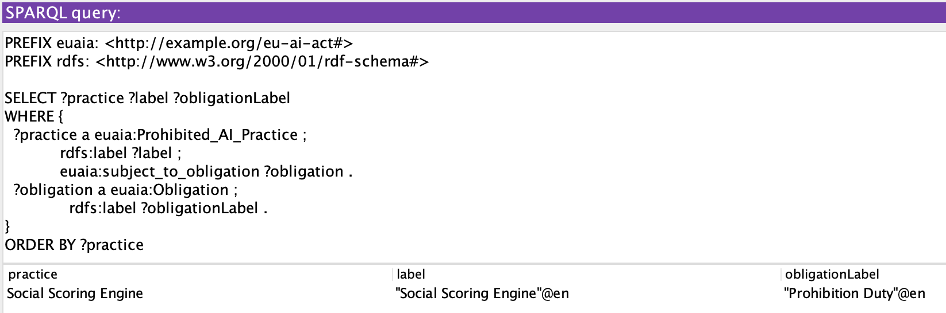
CQ4: Which governance entities regulate systems or govern actors?
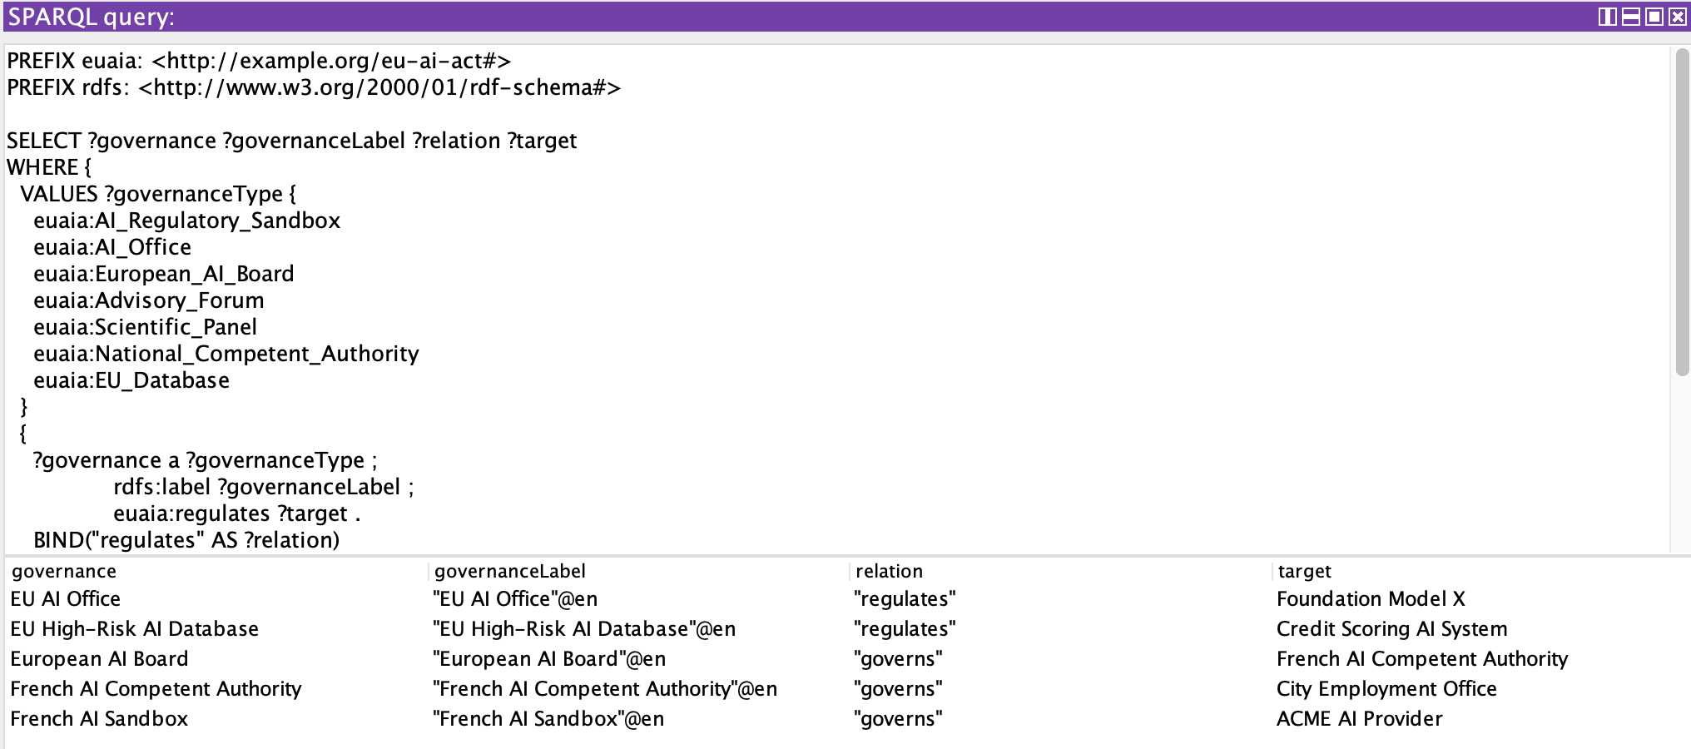
CQ5: Which GPAI models have systemic-risk obligations and who provides them?
